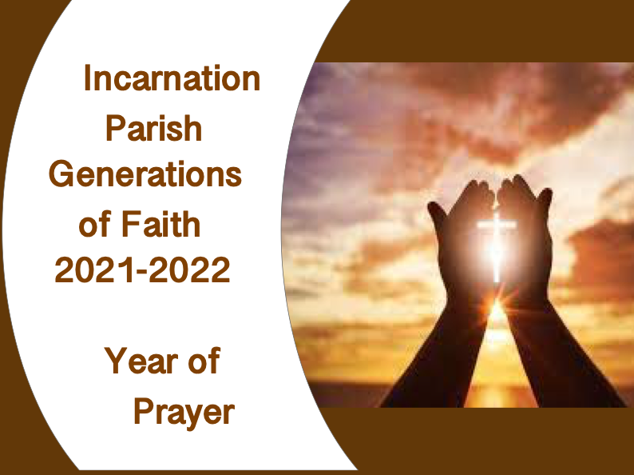
Incarnation Parish
Generations of Faith and Faith Formation
Master Calendar 2021-2022
Weekday Classes in Parish Hall 3:30-4:30

September
Orientation for new members after 9:30 mass on September 12
Mon 9/20 Grade 3
Tues 9/21 Grade 4
Wed 9/22 Grade 5
Thurs 9/23 Grade 6
Sun 9/26 following 9:30 Mass~ Meeting for Students in Grades 9&10 and their Parents
Tues 9/28 Grade 1

October
Generations of Faith Learning Event #1
Wed 10/13, or Thurs 10/14 6:00pm
…or Sat 10/16 9:00am
Sun 10/17 9:30 Grades 10 Mass &Class
Wed 10/20 Grade 2

November
Sun 11/7 Grade 7 & 8 9:30 Mass & Class
Tues 11/9 Grade 1
Wed 11/10 Grade 2
Sun 11/14 9:30 Grade 10 Mass & Class Mon 11/15 Grade 3
Tues 11/16 Grade 4
Wed 11/17 Grade 5
Thurs 11/18 Grade 6

December
Generations of Faith Learning Event #2
Wed 12/1 or Thurs 12/2 6:00pm
… or Sat 12/4 9:00am
Sun 12/5 9:30 Grade 9 Mass &Class
Sun 12/12 9:30 Grade 10 Mass &Class
Wed 12/15 Grade 2

January
Sun 1/9 9:30 Grades 7 & 8 Mass & Class
Mon 1/10 Grade 3
Tues 1/11 Grade 4
Wed 1/12 Grade 5
Thurs 1/13 Grade 6
Tues 1/18 Grade 1
Wed 1/19 Grade 2
Sun 1/23 9:30 Grade 10 Mass & Class

February
Generations of Faith Learning Event #3
Wed 2/2 or Thurs 2/3 6:00pm …
or Sat 2/5 9:00am
Sat Feb 5 4:30 Confirmation
Sun 2/13 9:30 Grade 9 Mass & Class
Wed 2/15 Grade 2

March
Sun 3/6 9:30 Grade 7&8 Mass & Class
Tues 3/8 Grade 1
Mon 3/14 Grade 3
Tues 3/15 Grade 4
Wed 3/16 Grade 5
Thurs 3/17 Grade 6
Sat 3/26 Grade 2 Reconciliation/Retreat 1:00pm
Sun 3/27 9:30 Grade 9 Mass & Class

April
Generations of Faith Learning Event #4
Wed 4/6 or Thurs 4/7 6:00pm …
or Sat 4/9 9:00am
First Communion Dates
April 30/May 1
May 7
May 14/15

