**Incarnation Parish**

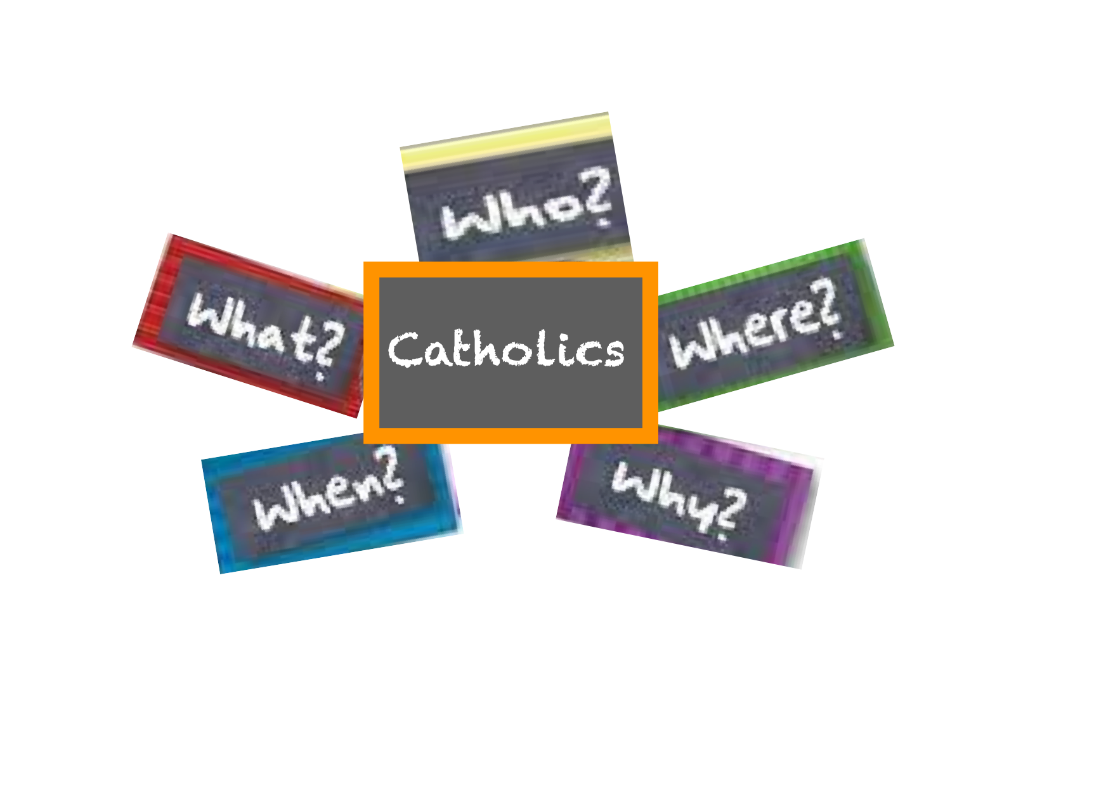

**Generations of Faith and Faith Formation**

**Master Calendar 2022-2023**

**Weekday Classes in Parish Hall 3:30-4:30**

**September**

**Sun 9/18 following 9:30** Mass~ **Meeting for Students in Grades 9&10 and their Parents**

Mon 9/19 Grade 3

Tues 9/20 Grade 4

Wed 9/21 Grade 5

Thurs 9/22 Grade 6

Tues 9/27 Grade 1

**October**

**Generations of Faith Learning Event #1**

**Wed 10/12, or Thurs 10/13,or Sat 10/15**

Sun 10/16 9:30 Grade 10 Mass &Class

Wed 10/19 Grade 2

**November**

Tues 11/1 Grade 1

Sun 11/6 Grade 7 & 8 9:30 Mass & Class

Wed 11/9 Grade 2

Sun 11/13 9:30 Grade 10 Mass & Class Mon 11/14 Grade 3

Tues 11/15 Grade 4

Wed 11/16 Grade 5

Thurs 11/17 Grade 6

Wed 11/30-GOF

**December**

**Generations of Faith Learning Event #2**

**Wed 11/30or Thurs 12/1 or Sat 12/3**

Sun 12/4 9:30 Grade 9 Mass &Class

Sun 12/11 9:30 Grade 10 Mass &Class

Wed 12/14 Grade 2

**January**

Sun 1/8 9:30 Grades 7 & 8 Mass & Class

Mon 1/9 Grade 3

Tues 1/10 Grade 4

Wed 1/11 Grade 5

Thurs 1/12 Grade 6

Tues 1/17 Grade 1

Wed 1/18 Grade 2

Sun 1/22 9:30 Grade 9 Mass &Class

January 28 9:30 Grade 10 Retreat/Service

**February**

**Generations of Faith Learning Event #3**

**Wed 2/1 or Thurs 2/2 or Sat 2/4**

Sun 2/5 9:30 Grade 9 Mass & Class

**Sat Feb 11 4:30 Confirmation**

Sun 2/12 9:30 Grade 2 Mass & Class

**March**

Sun 3/5 9:30 Grade 7&8 Mass & Class

Sunday 3/12 9:30 Grade 2Mass & Class Mon 3/13 Grade 3

Tues 3/14 Grade 4

Wed 3/15 Grade 5

Thurs 3/16 Grade 6

Tues 3/21 Grade 1

Sat 3/25 Grade 2 Reconciliation/Retreat 1:00pm

Sun 3/26 9:30 Grade 9 Mass & Class

**Generations of Faith Learning Event #4**

**Wed 3/29 or Thurs 3/30 or Sat 4/1**

**April**

**First Communion Dates**

**April 29/30, May 6/7, May 13, May 20**